# **Assignment 1 – Classification using Scikit-learn**

**Student Name**: Ya Li Lin (Kelly) **Student ID**: 22721291 **Programme**: 4BCT

## **Algorithm 1 – Logical Regression**

Logistic Regression is a well-established supervised learning algorithm used for binaryclassification problems [1]. Rather than predicting continuous values, it estimates the probability that something belongs to one of two possible classes, such as “fire” or “no fire” [2]. It achieves this by using a mathematical function that converts predictions into probabilities between 0 and 1. Because of its simplicity and clear interpretability, Logistic Regression is often used as a starting point before applying more complex machine learning techniques [2], [4].

**Detailed Description of Algorithm 1.**

Logistic Regression works by combining several input features into a single weighted sum, then passing that sum through a sigmoidfunction:

The sigmoid curve compresses all values into a range between 0 and 1, allowing them to be interpreted as probabilities [2], [4]. Predictions with probabilities of 0.5 or higher are classified as “fire”, while those below 0.5 are labelled “no fire” [3]. The model adjusts its weights to minimise error during training and often includes regularisation to prevent overfitting, which happens when a model fits the training data too closely [2]. Logistic Regression is fast, easy to train, and helps identify which input features are most influential. However, it assumes a linearrelationship between variables and cannot easily capture complex, non-linear interactions [5].

*Figure 1. Logistic Regression decision boundary showing a linear separation between two classes [1].*

**Why I choose this algorithm.**

I chose Logistic Regression because it’s straightforward, transparent, and provides an excellent baseline for comparison [1]. It lets me see which environmental factors, such as humidity or temperature, contribute most to wildfire risk. The model is easy to interpret, quick to train, and requires minimal computational power. Using Logistic Regression first also makes it easier to understand how a linear model performs before moving on to more complex approaches like Support Vector Machines (SVMs). This helps build up the analysis step by step [6].

**Hyperparameter Details for Tuning.**

***C****:* Inverse of regularisation strength. A small C applies stronger regularisation, simplifying the model but risking underfitting. A large C reduces regularisation, fitting more closely to training data but with a risk of overfitting [3], [4].

***Penalty****:* Determines the type of regularisation. L2 is most common, while “none” removes regularisation entirely [3].

## **Algorithm 2 – Support Vector Machines (SVM) with RBF Kernel**

Support Vector Machines (SVMs) are supervised learning algorithms that classify data by drawing the best possible boundary between two classes [1]. The idea is to maximise the margin between data points on either side of the line, giving the model more confidence in its predictions. When data cannot be separated with a straight line, an RBFkernel can be applied to create a flexible, curved boundary. This makes SVMs particularly effective for capturing complex, non-linear relationships [2], [4].

**Detailed Description of Algorithm 2.**

SVMs work by identifying supportvectors, which are the key data points closest to the decision boundary [1]. The algorithm finds the boundary that separates the classes with the widest possible margin, which usually leads to better performance on unseen data. The RadialBasis Function (RBF) kernel allows SVMs to model curved, non-linear boundaries by transforming the data into a higher-dimensional space. This transformation is achieved through the kernel trick, calculated using:

*Figure 2. Radial Basis Function (RBF) kernel used in Support Vector Machines [4].*

Here, the parameter γ (gamma) controls how tightly the boundary curves around the data [2]. SVMs often achieve high accuracy but can take longer to train and are less interpretable than simpler models such as Logistic Regression [3], [4]..

Figure : Graphic illustration of how the algorithm works

**Why I choose this algorithm.**

I selected the SVM with an RBF kernel because it handles non-linear and overlapping data very well [1], [2]. Wildfire patterns are unlikely to follow simple, straight-line relationships, so the flexibility of the RBF kernel is a major advantage. SVMs are also quite robust to outliers, which is useful for environmental data where some measurements may be noisy. Comparing the SVM with Logistic Regression allows me to explore both a linear and a non-linear approach, highlighting which method better captures patterns in the dataset [4].

**Hyperparameter Details for Tuning.**

***C****:* Balances margin width and accuracy. Higher C values fit the training data more closely, while lower C values allow a softer margin [2], [3].

***Gamma (γ):*** Defines how far the influence of a single point extends. A small γ gives a smooth, simple boundary; a large γ makes it complex [3], [4].

**Algorithm 1 - <Name of Algorithm> - Model Training and Evaluation**

<Introduction> Purus semper eget duis at tellus. Ultricies tristique nulla aliquet enim tortor at auctor urna nunc. Pharetra massa massa ultricies mi quis. Maecenas sed enim ut sem viverra aliquet eget sit. Feugiat sed lectus vestibulum mattis ullamcorper velit. Vitae auctor eu augue ut lectus arcu bibendum. Pellentesque dignissim enim sit amet. Massa tempor nec feugiat nisl pretium

**Data Preprocessing and Visualisation**

Nulla facilisi cras fermentum odio. Imperdiet nulla malesuada pellentesque elit eget gravida cum sociis. Tortor vitae purus faucibus ornare suspendisse sed nisi lacus. Dapibus ultrices in iaculis nunc sed augue lacus viverra vitae. Tellus id interdum velit laoreet id donec ultrices tincidunt. Magna ac placerat vestibulum lectus. Diam

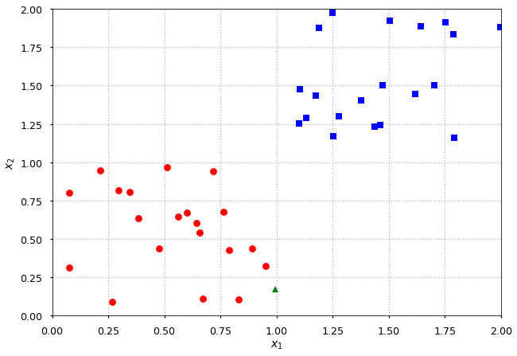

Figure : Visualisation of the dataset before training

**Training and Evaluation Details**

Nunc eget lorem dolor sed. Duis convallis convallis tellus id interdum. In hendrerit gravida rutrum quisque non tellus orci. Sed libero enim sed faucibus turpis in eu. Sem viverra aliquet eget sit amet tellus cras adipiscing enim. Nulla facilisi cras fermentum odio. Imperdiet nulla malesuada pellentesque elit eget gravida cum sociis. Tortor vitae purus faucibus ornare suspendisse sed nisi lacus. Dapibus ultrices in iaculis nunc sed augue lacus viverra vitae. Tellus id interdum velit laoreet id donec ultrices tincidunt. Magna ac placerat vestibulum lectus. Diam donec adipiscing tristique risus nec feugiat in fermentum.

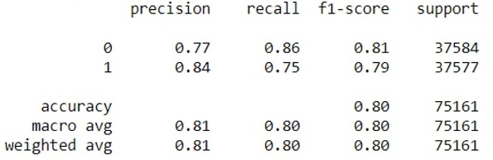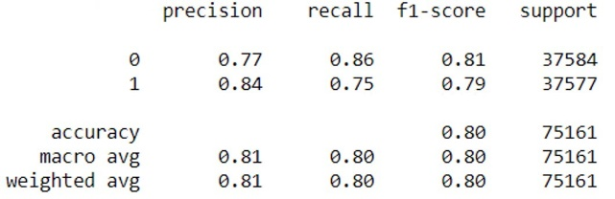

Figure : Summary of Results Achieved from Training and Testing

**Discussion of results**

Sed libero enim sed faucibus turpis in eu. Sem viverra aliquet eget sit amet tellus cras adipiscing enim. Nulla facilisi cras fermentum odio. Imperdiet nulla malesuada pellentesque elit eget gravida cum sociis. Tortor vitae purus faucibus ornare suspendisse sed nisi lacus. Dapibus ultrices in iaculis nunc sed augue lacus viverra vitae. Tellus id interdum velit laoreet id donec ultrices tincidunt. Magna ac placerat vestibulum lectus. Diam donec adipiscing tristique risus nec feugiat in fermentum.

**Algorithm 2 - <Name of Algorithm> - Model Training and Evaluation**

<Introduction> Purus semper eget duis at tellus. Ultricies tristique nulla aliquet enim tortor at auctor urna nunc. Pharetra massa massa ultricies mi quis. Maecenas sed enim ut sem viverra aliquet eget sit. Feugiat sed lectus vestibulum mattis ullamcorper velit.

**Data Preprocessing and Visualisation**

Nulla facilisi cras fermentum odio. Imperdiet nulla malesuada pellentesque elit eget gravida cum sociis. Tortor vitae purus faucibus ornare suspendisse sed nisi lacus.

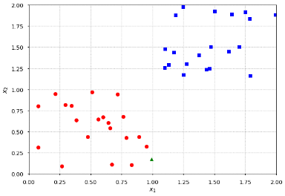

Figure : Visualisation of the dataset before and after pre-processing was applied

Dapibus ultrices in iaculis nunc sed augue lacus viverra vitae. Tellus id interdum velit laoreet id donec ultrices tincidunt. Magna ac placerat vestibulum lectus. Diam. . Vitae auctor eu augue ut lectus arcu bibendum. Pellentesque dignissim enim sit amet. Massa tempor nec feugiat nisl pretium

**Training and Evaluation Details**

Nunc eget lorem dolor sed. Duis convallis convallis tellus id interdum. In hendrerit gravida rutrum quisque non tellus orci. Sed libero enim sed faucibus turpis in eu. Sem viverra aliquet eget sit amet tellus cras adipiscing enim.



Figure : Summary of Results Achieved from Training and Testing

Nulla facilisi cras fermentum odio. Imperdiet nulla malesuada pellentesque elit eget gravida cum sociis. Tortor vitae purus faucibus ornare suspendisse sed nisi lacus. Dapibus ultrices in iaculis nunc sed augue lacus viverra vitae. Tellus id interdum velit laoreet id donec ultrices tincidunt. Magna ac placerat vestibulum lectus. Diam donec adipiscing tristique risus nec feugiat in fermentum.

**Discussion of results**

Sed libero enim sed faucibus turpis in eu. Sem viverra aliquet eget sit amet tellus cras adipiscing enim. Nulla facilisi cras fermentum odio. Imperdiet nulla malesuada pellentesque elit eget gravida cum sociis. Tortor vitae purus faucibus ornare suspendisse sed nisi lacus. Dapibus ultrices in iaculis nunc sed augue lacus viverra vitae. Tellus id interdum velit laoreet id donec ultrices tincidunt. Magna ac placerat vestibulum lectus. Diam donec adipiscing tristique risus nec feugiat in fermentum.

**Conclusions**

Tortor vitae purus faucibus ornare suspendisse sed nisi lacus. Dapibus ultrices in iaculis nunc sed augue lacus viverra vitae. Tellus id interdum velit laoreet id donec ultrices tincidunt. Magna ac placerat vestibulum lectus. Diam donec adipiscing tristique risus nec feugiat in fermentum.

**Key Findings**

* Sem viverra aliquet eget sit amet tellus cras adipiscing enim. Nulla facilisi cras
* Sem viverra aliquet eget sit amet tellus cras adipiscing enim. Nulla facilisi cras
* Sem viverra aliquet eget sit amet tellus cras adipiscing enim. Nulla facilisi cras
* Sem viverra aliquet eget sit amet tellus cras adipiscing enim. Nulla facilisi cras
* Sem viverra aliquet eget sit amet tellus cras adipiscing enim. Nulla facilisi cras

**Comparative Analysis of Algorithm Performances**

Purus semper eget duis at tellus. Ultricies tristique nulla aliquet enim tortor at auctor urna nunc. Pharetra massa massa ultricies mi quis. Maecenas sed enim ut sem viverra aliquet eget sit. Feugiat sed lectus vestibulum mattis ullamcorper velit. Vitae auctor eu augue ut lectus arcu bibendum. Pellentesque dignissim enim sit amet. Massa tempor nec feugiat nisl pretium

Purus semper eget duis at tellus. Ultricies tristique nulla aliquet enim tortor at auctor urna nunc. Pharetra massa massa ultricies mi quis. Maecenas sed enim ut sem viverra aliquet eget sit. Feugiat sed lectus vestibulum mattis ullamcorper velit. Vitae auctor eu augue ut lectus arcu bibendum. Pellentesque dignissim enim sit amet. Massa tempor nec feugiat nisl pretium

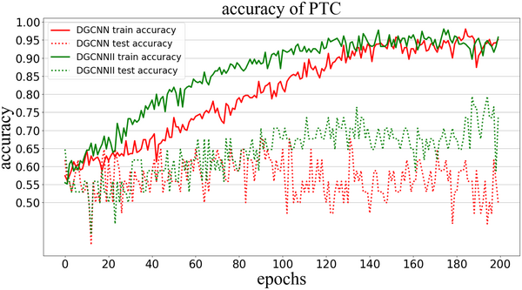 

Figure : Graphed comparison of results from the two algorithms

**Recommended Hyperparameter Valued based on Results**

*Algorithm 1 Hyperparamer 1:* purus faucibus ornare suspendisse sed nisi lacus. Dapibus ultrices *Algorithm 1 Hyperparamer 2:* purus faucibus ornare suspendisse sed nisi lacus. Dapibus ultrices

*Algorithm 2 Hyperparamer 1:* purus faucibus ornare suspendisse sed nisi lacus. Dapibus ultrices *Algorithm 2 Hyperparamer 2:* purus faucibus ornare suspendisse sed nisi lacus. Dapibus ultrices

**Concluding Remarks**

Maecenas sed enim ut sem viverra aliquet eget sit. Feugiat sed lectus vestibulum mattis ullamcorper velit. Vitae auctor eu augue ut lectus arcu bibendum. Pellentesque dignissim enim sit amet. Massa tempor nec feugiat nisl pretium. viverra aliquet eget sit. Feugiat sed lectus vestibulum mattis ullamcorper velit. Vitae auctor eu augue. viverra aliquet eget sit. Feugiat sed lectus vestibulum mattis ullamcorper velit. Vitae auctor eu augue.

**References**

1. [1] CT4101 Module Notes, “Classification,” School of Computer Science, University of Galway, 2025.
2. [2] C. M. Bishop, *Pattern Recognition and Machine Learning*. Springer, 2006.Reference any books, articles, blogs, documentation, videos etc. here…
3. [3] scikit-learn, “Logistic Regression,” [Online]. Available: <https://scikit-learn.org/stable/modules/linear_model.html>Reference any books, articles, blogs, documentation, videos etc. here…
4. [4] scikit-learn, “SVM with RBF kernel parameters,” [Online]. Available: <https://scikit-learn.org/stable/auto_examples/svm/plot_rbf_parameters.html>Reference any books, articles, blogs, documentation, videos etc. here…
5. [5] GeeksforGeeks, “Understanding Logistic Regression,” [Online]. Available: <https://www.geeksforgeeks.org/machine-learning/understanding-logistic-regression/>Reference any books, articles, blogs, documentation, videos etc. here…
6. [6] D. W. Hosmer and S. Lemeshow, *Applied Logistic Regression*. Wiley, 2nd ed., 2000.Reference any books, articles, blogs, documentation, videos etc. here…
7. [7] GeeksforGeeks, “RBF SVM Parameters in scikit-learn,” [Online]. Available: <https://www.geeksforgeeks.org/python/rbf-svm-parameters-in-scikit-learn/>Reference any books, articles, blogs, documentation, videos etc. here…
8. [8] S. Mallat, “A tutorial on support vector machines for pattern recognition,” École Normale Supérieure, 1999. [Online]. Available: <https://www.di.ens.fr/~mallat/papiers/svmtutorial.pdf>Reference any books, articles, blogs, documentation, videos etc. here…
9. Reference any books, articles, blogs, documentation, videos etc. here…
10. Reference any books, articles, blogs, documentation, videos etc. here…
11. Reference any books, articles, blogs, documentation, videos etc. here…
12. Reference any books, articles, blogs, documentation, videos etc. here…
13. Reference any books, articles, blogs, documentation, videos etc. here…

**Report Update Log**

|  |  |  |
| --- | --- | --- |
| Date | Update Description | Time Spent |
| 20/09/25 | Purus semper eget duis at tellus. Ultricies tristique nulla aliquet enim tortor at auctor urna nunc. Pharetra massa massa ultricies mi quis. | 2 hours |
| 22/09/25 | Purus semper eget duis at tellus. Ultricies tristique nulla aliquet enim tortor at auctor urna nunc. Pharetra massa massa ultricies mi quis. | 2 hours |
| 25/09/25 | Purus semper eget duis at tellus. Ultricies tristique nulla aliquet enim tortor at auctor urna nunc. Pharetra massa massa ultricies mi quis. | 1 hour |
| 26/09/25 | Purus semper eget duis at tellus. Ultricies tristique nulla aliquet enim tortor at auctor urna nunc. Pharetra massa massa ultricies mi quis. | 30 mins |
| 27/09/25 | Purus semper eget duis at tellus. Ultricies tristique nulla aliquet enim tortor at auctor urna nunc. Pharetra massa massa ultricies mi quis. | 1 hour |
| 30/09/25 | Purus semper eget duis at tellus. Ultricies tristique nulla aliquet enim tortor at auctor urna nunc. Pharetra massa massa ultricies mi quis. | 3 hours |
| 02/10/25 | Purus semper eget duis at tellus. Ultricies tristique nulla aliquet enim tortor at auctor urna nunc. Pharetra massa massa ultricies mi quis. | 2 hours |
| 04/10/25 | Purus semper eget duis at tellus. Ultricies tristique nulla aliquet enim tortor at auctor urna nunc. Pharetra massa massa ultricies mi quis. | 2 hours |
| 05/10/25 | Purus semper eget duis at tellus. Ultricies tristique nulla aliquet enim tortor at auctor urna nunc. Pharetra massa massa ultricies mi quis. | 4 hours |
| 07/10/25 | Purus semper eget duis at tellus. Ultricies tristique nulla aliquet enim tortor at auctor urna nunc. Pharetra massa massa ultricies mi quis. | 30 mins |
| 12/10/25 | Purus semper eget duis at tellus. Ultricies tristique nulla aliquet enim tortor at auctor urna nunc. Pharetra massa massa ultricies mi quis. | 1 hour |
| 14/10/25 | Purus semper eget duis at tellus. Ultricies tristique nulla aliquet enim tortor at auctor urna nunc. Pharetra massa massa ultricies mi quis. | 3 hours |
| 15/10/25 | Purus semper eget duis at tellus. Ultricies tristique nulla aliquet enim tortor at auctor urna nunc. Pharetra massa massa ultricies mi quis. | 30 mins |
| 16/10/25 | Purus semper eget duis at tellus. Ultricies tristique nulla aliquet enim tortor at auctor urna nunc. Pharetra massa massa ultricies mi quis. | 1 hour |
|  |  |  |
|  |  |  |
|  |  |  |
|  |  |  |
|  |  |  |
|  |  |  |
|  |  |  |
|  |  |  |